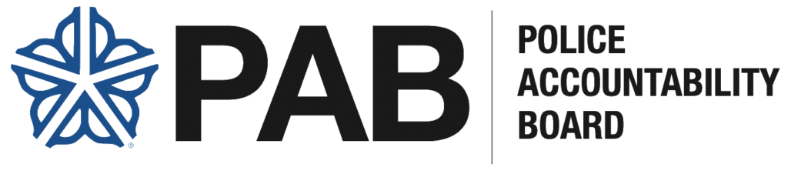
Police Accountability Board (PAB) Meeting Agenda
Date: Thursday, March 5, 2026
Time: 6:00 PM – 7:30 PM ET
Location: Livestreamed via YouTube or attend in person at 30 Church Street, Rochester, New York 14614
ASL Interpreters: Jim Brown

1. Welcome & Introductions
- Opening Remarks

2. Approval of Meeting Minutes
- January 8, 2026 (Distributed to Board members on January 26, 2026, for review)

3. Executive Director Report
- Body-Worn Camera Access and Oversight Operations Update
- Strategic Plan and KPI Update
4. PAB Departmental Updates
- Accountability and Transparency
- Operations
- Policy and Oversight
- Public Affairs and Community Engagement

5. Chair Report
- Chair Updates

6. Committee Reports
- Training Committee – Board Members William Clark and Larry Knox
- Youth & Community Engagement Committee – Board Members Lwam Tecleab and Yvonne Wilson

8. Old Business

9. New Business

10. Executive Session

11. Meeting Close

